Friday, October 07, 2011

Mr. Donald Osborn Chesworth III Email: dchesworth@gmail.com
4300 Normal Avenue Phone: 510-691-6401
Los Angeles, CA 90029

Renwick/Chesworth Wedding Group

REF: Renwick/Chesworth Wedding Group- January 19-21, 2012
10 # Rooms per Night
Windward Passage Hotel

Dear Mr. Chesworth:

Thank you for your interest in the Windward Passage Hotel for your guest accommodations.

Windward Passage Hotel offers a city center location in the heart of Charlotte Amalie,
perfect for your next meeting, function, or executive corporate event. Gracing the waterfront of picturesque Charlotte Amalie; this landmark hotel is known for its proximity to multiple Corporate Offices and business headquarters.

This Downtown Hotel offers 151 Harbor View & Mountain View distinctive accommodations including 11 Junior Suites. In addition, the Hotel offers multiple options with three air-conditioned meeting rooms with a Boardroom & Executive Business Lounge with over 3000 sq feet of indoor meeting space and over 5000 sq feet of outdoor pool terrace, courtyard and reception space.

Specializing in small and mid-size meetings and events from 15-150 persons, Windward Passage offers affordable guest accommodations, indoor and outdoor banquet facilities all complemented by creative menu options & friendly attentive service carefully presented with a Caribbean Flair.

The World Class Duty Free Shops, many picturesque restaurants and St. Thomas’s entertainment & nightlife are all just outside your door. The downtown waterfront location is just 10 minutes from the Airport and offers daily shuttle service to the world renown Magen’s Bay Beach for agenda specific “Sun” Time.

Based on your needs, as I understand them, following please find our proposal for the Renwick/Chesworth Wedding Group. At the Windward Passage Hotel we pride ourselves in offering outstanding service and hospitality. At your request, it would be our pleasure to put the above dates on hold for you for a minimum of 30-days.

Our management and staff look forward to welcoming you to the Caribbean’s Boutique Alternative for Today’s Savvy Planner. Please do not hesitate to contact me at 340-774-5200 or via email at kgreaux@windwardpassage.com should you need further information.

Sales and Events Manager
Windward Passage Hotel

Group Name: Renwick/Chesworth Wedding Group

Hotel: Windward Passage Hotel

Available Dates: ARRIVAL: 1/19/12 DEPARTURE: 1/21/12
Peak Number of Rooms per Night: 10 Rooms – 0 Suites

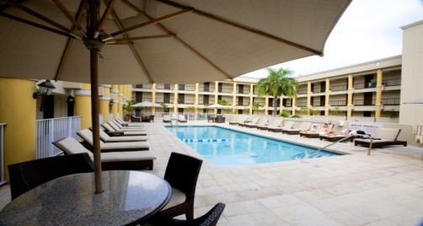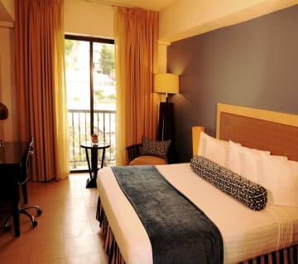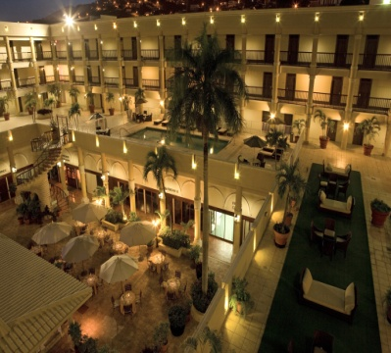
SPECIAL GROUP RATE – ROOMS US$
Start Date | End Date | Room Type | Single/Double
1/19/12 | 1/21/12 | Island View Room | $149
1/19/12 | 1/21/12 | Harbor View Room | $169
*Note: Run of House Accommodations would typically include a combination of King and Double-Double bedded rooms in both Island View, some Partial Harbor Views & Harbor View Types.

SPECIAL GROUP RATE – SUITES US$
Start Date | End Date | Suite Type | Single/Double
1/19/12 | 1/21/12 | Island View Jr. Suite | $219
1/19/12 | 1/21/12 | Harbor View Jr. Suite | $265

Accommodation Highlights
- Frigate Bay House (main building) features West Indies-accented guest rooms located on Floors 1-4, The Fifth Floor is comprised of 1-Bedroom Royal Golf View & Royal Ocean View Suites.
- Our Three – Storey Garden Villas contain Standard, Deluxe, Pool View & Ocean View rooms as well as Resort View & Ocean View 1-, 2- and 3-bedroom suites
- Dedicated high speed line service internet access in rooms, wireless capability available lobby level public spaces at this time.
- Most guest rooms include large private balconies with garden, pool or ocean views
- Luxurious baths feature massage showerheads; Main Building Suite baths feature a whirlpool tub and shower. All Garden Villa units regardless of category distinction feature a whirlpool tub.
- All guest rooms offer coffee makers, CD/alarm clocks, hair dryers, and refrigerators/mini-bar.

Prices are quoted per room, per night single or double occupancy

Rates are subject to 10% Government Tax and 10% Resort Fee per room per night which includes daily maid services, complimentary internet, and energy surcharge.

Rate is quoted EP – European Plan net non-commissionable
- Additional Person Charges apply at $25 per person per day over two in guest rooms
- Customized Meal Plans are available at an additional charge

Rates will be valid for 30 days from proposal issuance date
- Rates are based on a minimum of 10 rooms per night
- Estimated Airport Transfers costs of $28.00 roundtrip per person

RESERVATIONS:

(Individuals making reservations)
▪ Reservations for the Event will be made by individual attendees directly with
Windward Passage Hotel reservations at 1-800-524-7389, with Hotel directly at
340-774-5200 or via fax to 340-774-5582.

▪ Upon booking, please notify guests to inform the reservations agent that they are
a part of the Renwick/Chesworth Wedding Group in order to receive group rate.

▪ Upon booking, a one night deposit will be charged in order to guarantee their
guest room. This deposit will be fully refundable up until three days prior to
arrival.

BENEFITS TO GUESTS/CONCESSIONS:
- Complimentary Private Check-in area. All guests pre-registered and pre-keyed.
- Welcome drink coupon upon arrival (Non Alcoholic)
- Complimentary Fitness Room (Spa Services Additional)
- Discounted Meeting Room Rental based on overall hotel spend.
- Group rate extended (3) days prior and (3) days after departure, based on availability

GRATUITIES/SERVICE CHARGE:
All Rooms and Suites are subject to and additional charge for the following:
Bellmen - US$ 5.00* per person round trip

CHECK IN / CHECK OUT:
Check in time is after 4:00 pm and check out time is at 12:00 Noon

Meal Pricing
Individual Breakfast at Leisure (On own)  Private Events (2011 Banquet Menus):  Continental Breakfast  Refreshment Break  Breakfast Buffet  Brunch & Lunches  Boxed Lunches  Dinner & Theme Buffets  Plated Dinners  Reception Hot Hors’d oeuvres (trays)  Reception Cold Hors’d oeuvres (trays)  Reception (beverage only) | $9.95 – $22.95 per person/per day  (plus 15% gratuity-dining in restaurant)  $13.95-$18.95 per person*  $12.95-$15.95 per person*  $19.95-$25.95 per person*  $21.95-$36.95 per person*  $15.95 per person*  $34.95-$59.95 per person*  $25.95-$34.95 per person*  $79.00-$255.00 per tray*  $79.00-$95.00 per tray*  $18.00 pp-1st hour *$16.00pp Add. hrs.

*All prices are estimates and subject to change / *Current pricing, please anticipate 10% annual increase / Banquet Food & Beverage Gratuity/Service Charge 20%

BANQUET / FUNCTION SPACE COMMITMENT:

The attached Function Information Agenda reflects your Meeting/Banquet needs as we currently understand them.

FUNCTION INFORMATION AGENDA:

Date | Day | Start Time | End Time | Function Type | Setup | # PAX | Conference Room Rental Fee | Function Room Service Fee (if any)
1/19/12 | THURS | FLOW | FLOW | Check-in |  | 20 | N/A | N/A
1/20/12 | FRI | FLOW | FLOW | B.L,D on Own | AS IS | 20 | N/A | N/A
1/21/12 | SAT | FLOW | FLOW | Check-out |  | 20 | N/A | N/A

Suggested Destination Management Companies

Caribbean Tour Services Island Meeting’s & Incentives
Mr. Philip Shannon Ms. Judi Nagelberg
Ms. Melinda Comstock Mr. Tom Cornwall
P.O. Box 12319 6100 Red Hook Qtr., Ste A2-1
St. Thomas, VI 00801 St. Thomas, VI 00802
Tel: (340) 776 3650 Tel: (340) 779 2755
Fax: (340) 775 1536 Fax: (340) 779-2886
cts@islands.vi judi@imi.vi
www.caribbeantourservices.com www.imivi.com
Premier Destination Services Tropic Tours
Mr. Tom Hoffman Ms. Brooks Reid Brown
Ms. Susan Lysghat Ms. Courtney Brown Gabrielson
P. O. Box 302665 P.O. Box 301855
St. Thomas, VI 00803-2665 St. Thomas, VI 00803-1855
Tel: (340) 714-1737 Tel: (340) 774-1855
Fax: (340) 776-1737 Fax: (340) 776-9597
thoffman@premierdestinationsservices.net brooks@tropictoursusvi.com
www.premierdestinationsservices.net www.tropictoursusvi.com

